**Probability and Statistics (UCS410)**

**Experiment 3: Probability distributions**

**(1) Roll 12 dice simultaneously, and let X denotes the number of 6’s that appear. Calculate the probability of getting 7, 8 or 9, 6’s using R. (Try using the function pbinom; If we set S = {get a 6 on one roll}, P(S) = 1/6 and the rolls constitute Bernoulli trials; thus X ∼ binom(size=12, prob=1/6) and we are looking for P(7 ≤ X ≤ 9).**

**CODE:**

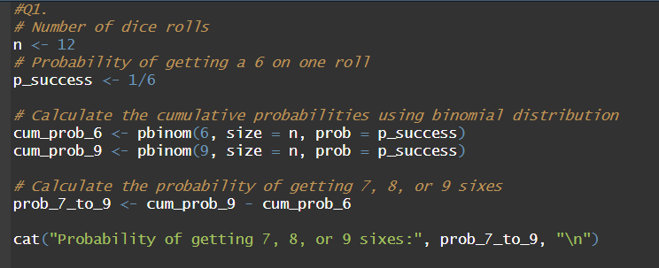

**OUTPUT:**

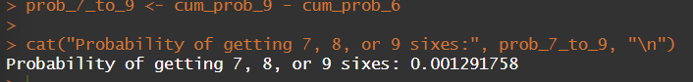

**CODE(USING dbinom):**

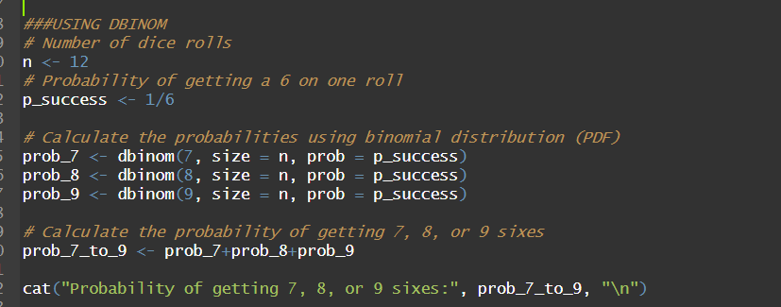

**OUTPUT:**

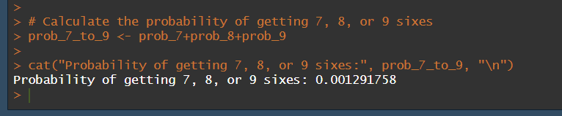

**(2) Assume that the test scores of a college entrance exam fits a normal distribution. Furthermore, the mean test score is 72, and the standard deviation is 15.2. What is the percentage of students scoring 84 or more in the exam?**

**CODE:**

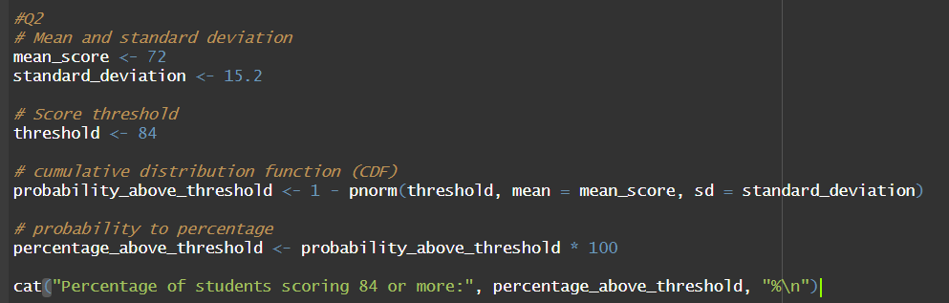

**OUTPUT:**

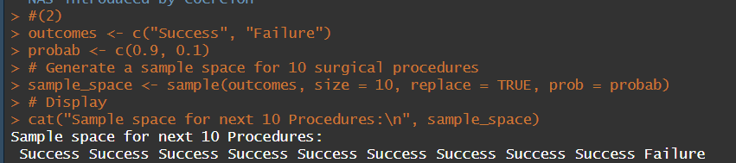



**(3) On the average, five cars arrive at a particular car wash every hour. Let X count the number of cars that arrive from 10AM to 11AM, then X ∼Poisson(λ = 5). What is probability that no car arrives during this time. Next, suppose the car wash above is in operation from 8AM to 6PM, and we let Y be the number of customers that appear in this period. Since this period covers a total of 10 hours, we get that Y ∼ Poisson(λ = 5×10 = 50). What is the probability that there are between 48 and 50 customers, inclusive?**

**CODE:**

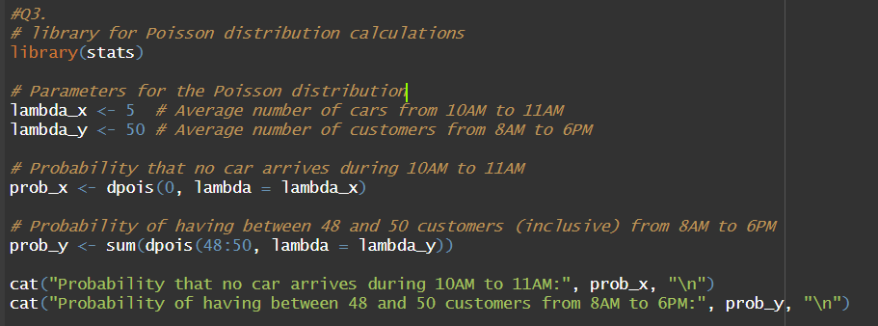

**OUTPUT:**

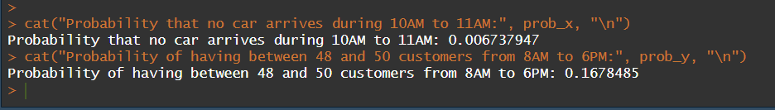

**(4) Suppose in a certain shipment of 250 Pentium processors there are 17 defective processors. A quality control consultant randomly collects 5 processors for inspection to determine whether or not they are defective. Let X denote the number of defectives in the sample. Find the probability of exactly 3 defectives in the sample, that is, find P(X = 3).**

**CODE:**

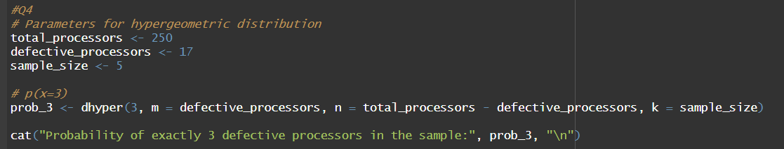

**OUTPUT:**

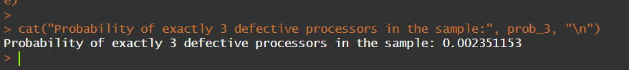

**(5) A recent national study showed that approximately 44.7% of college students have used Wikipedia as a source in at least one of their term papers. Let X equal the number of students in a random sample of size n = 31 who have used Wikipedia as a source.**

**(a) How is X distributed?**

**(b) Sketch the probability mass function.**

**(c) Sketch the cumulative distribution function.**

**(d) Find mean, variance and standard deviation of X.**

**CODE:**

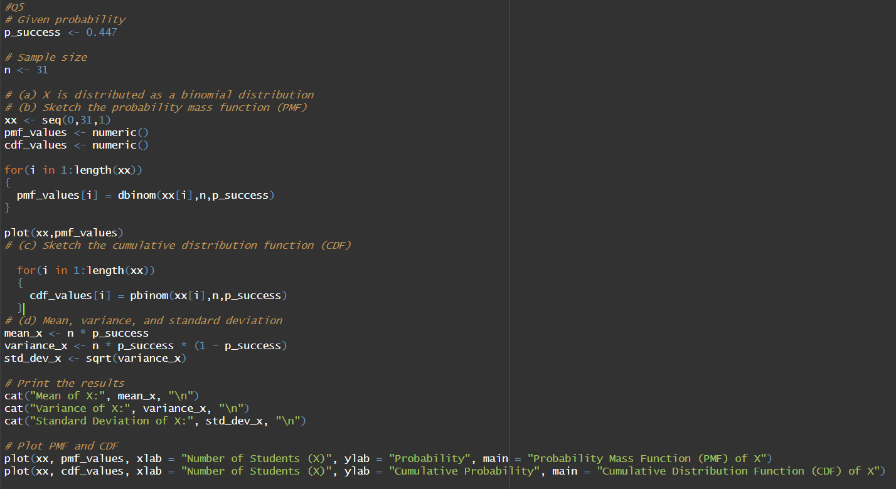

**OUTPUT:**

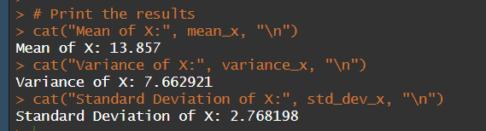

**PLOTS:**

*PDF: plot(xx, pmf_values, xlab = "Number of Students (X)", ylab = "Probability", main = "Probability Mass Function (PMF) of X")*

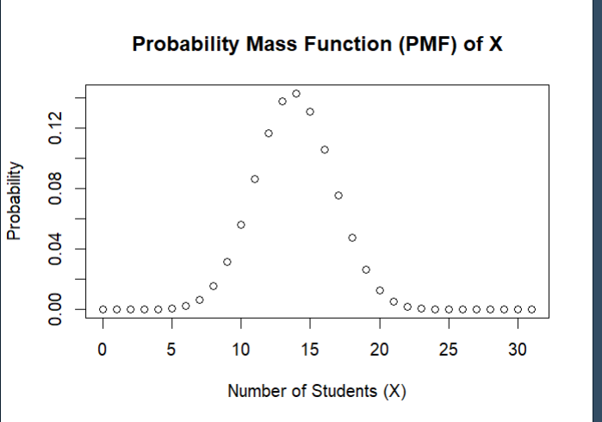

*CDF: plot(xx, cdf_values, xlab = "Number of Students (X)", ylab = "Cumulative Probability", main = "Cumulative Distribution Function (CDF) of X")*

